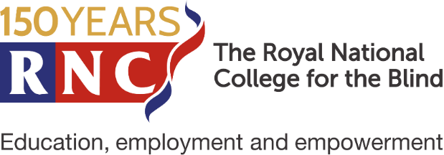

Open Day Booking Form
Friday 7th October 2022

Young Person Details
Full name
Known as
Home Address
(including postcode)
Date of Birth

Accompanying Adult Details
Relationship to Young Person
Full name
Known as
Home Address
(including postcode)
Phone Number
Email Address

Additional Accompanying Adult Details (if applicable)
Relationship to Young Person
Full name
Known as
Home Address
(including postcode)
Phone Number
Email Address

Medical & Mobility Information
Is the young person registered blind or partially sighted?
What eye condition(s) does the young person have?
How does this affect the young person?
Is there any additional information about you would like us to know? (e.g. medical conditions, accessibility arrangements)
Has the young person got any special dietary requirements?

Additional Information
What subject areas are the young person interested in?
Do you have an EHCP or statement? If so, what local authority do you come under and when is your next annual review?
If the young person is currently in education, what is the Name and Location of School or College?
If travelling by car, please write the vehicle’s registration number.

Please email the form to:
info@rnc.ac.uk

Or, post the form to:
Student Recruitment Team
The Royal National College for the Blind
Venns Lane, Hereford, HR1 1DT

